**Software Installation for the IoT Program**

1. **Arduino IDE and Drivers for NodeMCU/Wemos**

Step by Step Procedure :

1. First of all go the Arduino Website (<www.arduino.cc>) and click on the software and as per our operating system download the [Arduino IDE](https://www.arduino.cc/download_handler.php?f=/arduino-1.8.5-windows.zip) on your computer system.
2. After downloading of the IDE on your system Run the Arduino.exe (For windows) and once the IDE launched close the application.
3. Now We need to install the drivers for our Node MCU/Wemos Board so click on the link below to download the driver for the windows. (If you have another OS then go to the website of Silicon Labs, Chose your OS and download the drivers )

**FOR NODEMCU :**

<https://www.silabs.com/documents/public/software/CP210x_Windows_Drivers.zip>

**FOR WEMOS :**

<https://wiki.wemos.cc/downloads>

Click on windows to download the drivers

1. After downloading done, install the driver on your system and restart the computer.
2. Now after restarting your computer, we need to install the board libraries for NodeMCU/Wemos. So launch the Arduino IDE/application and **click on files tab>preferences**
3. Once Preferences window opens, you can see **additional Boards manager at the bottom.** So in that column paste the below mentioned URL and click on OK

[**http://arduino.esp8266.com/stable/package_esp8266com_index.json**](http://arduino.esp8266.com/stable/package_esp8266com_index.json)

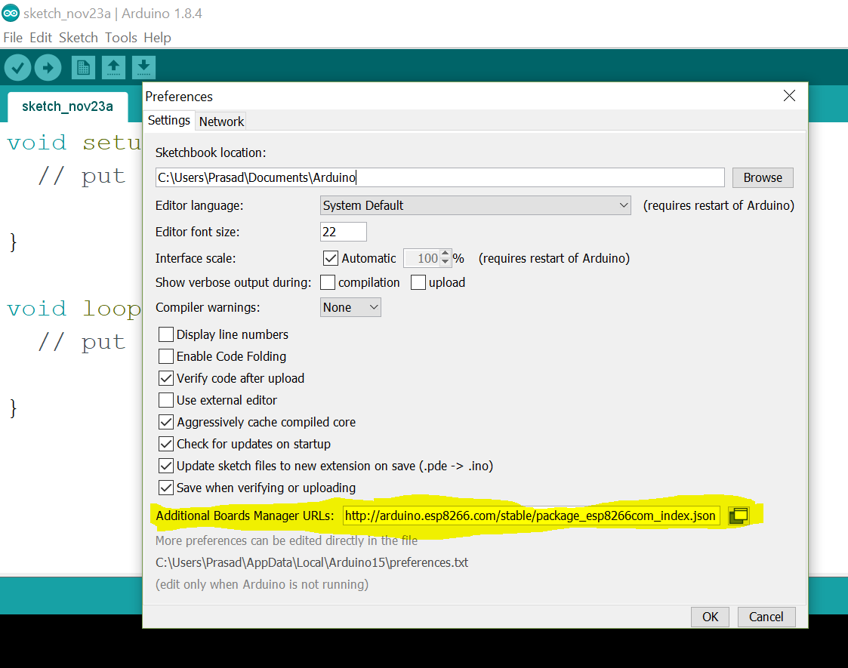

1. Now click on the tools>boards>Boards Manager

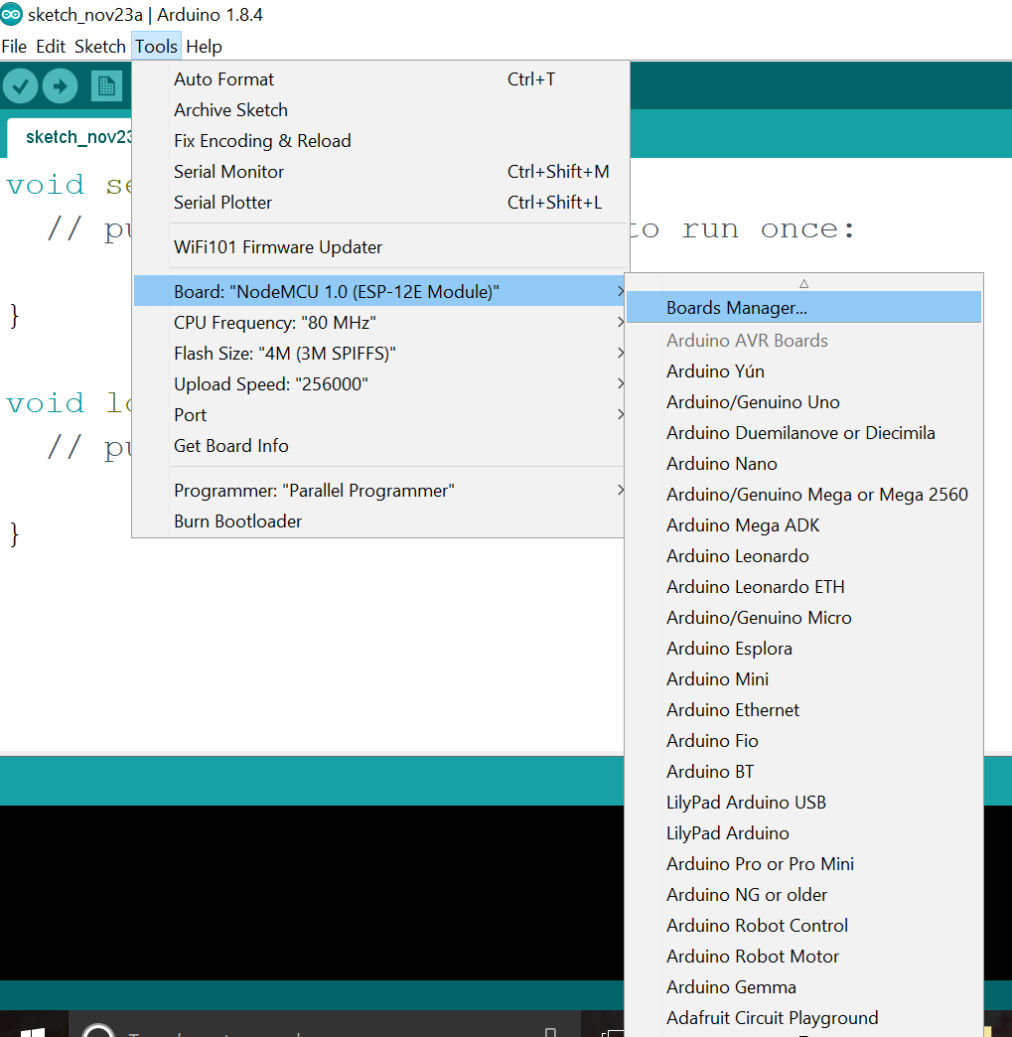

1. Once the board manager opens, in search bar type “nocemcu/Wemos D1” , immediately you will get the nodemcu/Wemos Library
2. Click on the install and wait for some time, as it will get few minutes(depending upon your internet speed) to download and install on your system
3. Once the library installed close the window and click on the Tools>Boards and you will get the list of Arduino and other boards then choose the NodeMCU1.0/Wemos board from board list.

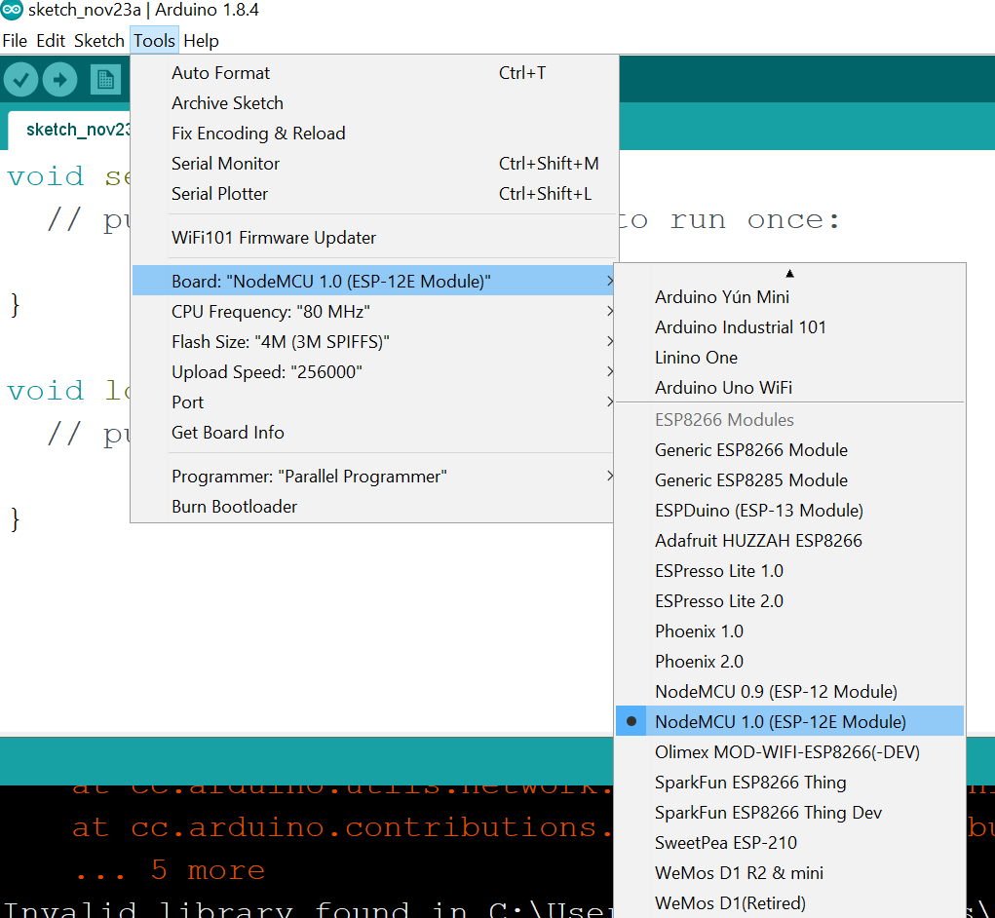

1. Now again click on tools and set the below mentioned parameters one by one
   1. CPU Frequency : 80 MHz
   2. Flash size : 4M
   3. Upload Speed :115200
   4. Port : COMport XX Will see during Workshop
2. **Other Software Installation**

* Install Google Chrome on Windows OS – Its compulsory
* Install RESTED APP or any REST Client App from Chrome Webstore
* <https://chrome.google.com/webstore/detail/rested/eelcnbccaccipfolokglfhhmapdchbfg>
* 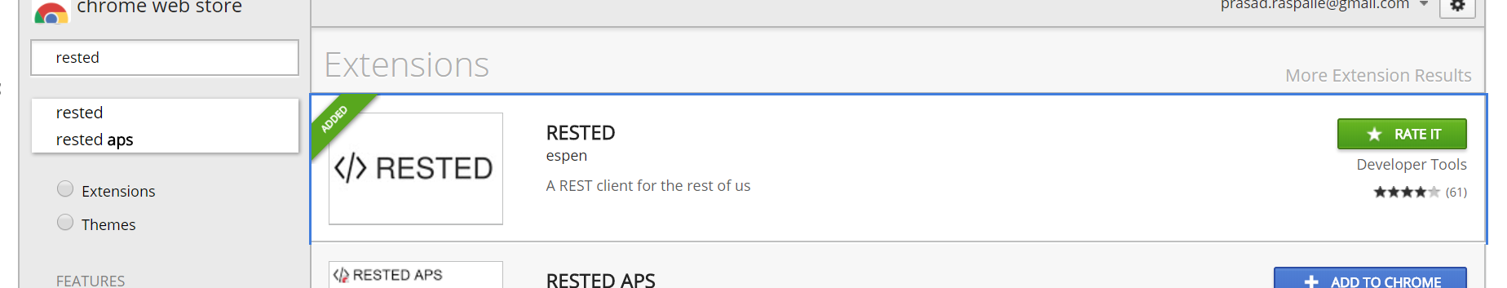
* For Raspberry Pi Download and install Below Mentioned Tools :
  + VNC Viewer : <https://www.realvnc.com/en/connect/download/viewer/>
  + Putty : - <https://www.chiark.greenend.org.uk/~sgtatham/putty/latest.html>
  + Visual Studio Code : <https://code.visualstudio.com/>

Other Instructions :

* Make sure you have good 4G Internet connection with Wifi Hotspot during all days of Workshop
* Please install [Slack messenger](https://slack.com/downloads/windows) in your Windows System and join the request sent on your Mail ID, We are going to use this Professional messenger for sharing day to day contents.
* Install [IFTTT Mobile App](https://play.google.com/store/apps/details?id=com.ifttt.ifttt&hl=en) (Available for Android and iOS) and register with your Google ID which you are going to use in Chrome during the workshop.
* Install [Google Assistant](https://play.google.com/store/apps/details?id=com.google.android.apps.googleassistant&hl=en) on your Android device and configure with your Google ID Which you are configuring for Chrome and IFTTT App.
* (Optional) [Register AWS](https://www.slideshare.net/simone.brunozzi/amazon-web-services-signup?next_slideshow=1) for with your credentials for future use :
* (Optional) Install [Reverb App](https://play.google.com/store/apps/details?id=agency.rain.android.alexa&hl=en) in Android if you have registered AWS Account.